1.

If P = {7, 9, 13}, Q = {1, 7, 13}. Find P ∩ Q.
A.
{1, 7, 13}
B.
{1, 9, 13}
C.
{7, 13}
D.
{7, 9, 13}
E.
{13}

2.

In the diagram, Q is the set of numbers inside the circle and T is the set of numbers inside the triangle. Find Q U T.
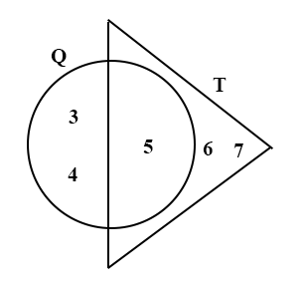
A.
{5}
B.
{6, 7}
C.
{3, 4, 5}
D.
{5, 6, 7}
E.
{3, 4, 5, 6, 7}

3.

Given that (23 × 82) × 79 = 148,994, find the exact value of (2.3 × 82) × 7.9
A.
14.8994
B.
148.994
C.
1489.94
D.
14899.4
E.
148994.0

4.

Convert 25_{ten} to a base two numeral.
A
A.
1000
B.
100111
C.
10101
D.
11001
E.
11100

5.

If (3.14 × 18) × 17.5 = 3.14 × (3a × 17.5). Find the value of a.
A.
3.0
B.
5.8
C.
6.0
D.
9.0
E.
18.0

6.

If 26039 oranges are shared equally among 13 women, how many oranges does each woman receive?
A.
23
B.
1203
C.
230
D.
2003
E.
2300

7.

Mr. Mensah withdrew some money from the bank. He gave
1
2
of it to his sons and
1
3
to his daughter. If he had ₵500.00 left, how much did he take from the bank?
A.
₵600.00
B.
₵750.00
C.
₵1500.00
D.
₵2000.00
E.
₵3000.00

8.

Simplify
1
2
(1
1
2
+
3
4
÷
1
4
)
A.
1
1
2
B.
2
1
4
C.
2
3
4
D.
4
1
2
E.
6

9.

If 21 : 2x = 7 : 10, find x.
A.
3
B.
2
1
4
C.
15
D.
35
E.
50

10.

X is a point on the line segment AB such that |AB| = 10 cm and |AX| = 4 cm.
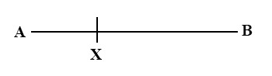
Find the ratio |AX| : |XB|
A.
5 : 3
B.
3 : 2
C.
5 : 4
D.
1 : 1
E.
2 : 3

11.

In an examination, 60% of the candidates passed. The number that passed was 240. How many candidates failed?
A.
140
B.
160
C.
360
D.
400
E.
600

12.

A table which cost ₵2,400.00 to manufacture was sold for ₵3,000.00. Find the profit percent.
A.
80%
B.
25%
C.
24%
D.
20%
E.
11.1%

13.

If a = 2² × 2³ ÷ 2⁴, find the value of a
A.
2⁹
B.
2⁵
C.
2²
D.
2
E.
20

14.

The distance between two towns is 12875 km.
Express this distance in standard form.
A.
1.2875 x 10³ km
B.
1.2875 x 10⁴ km
C.
12.875 x 10³ km
D.
128.75 x 10² km
E.
12.875 x 10⁴ km

15.

The pie chart shows the monthly expenditure of Mr. Awuah whose monthly income is ₵18,000.00.
Use the chart to answer the question below.
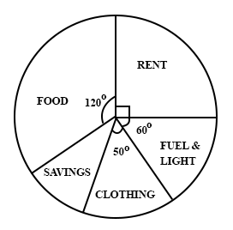
What fraction of Mr. Awuah's income is spent on food?
A.
1
6
B.
1
4
C.
1
3
D.
2
5
E.
1
2

16.

The pie chart shows the monthly expenditure of Mr. Awuah whose monthly income is ₵18,000.00.
Use the chart to answer the question below.
How much does Mr. Awuah spend on rent?
A.
₵90.00
B.
₵450.00
C.
₵4,500.00
D.
₵9,000.00
E.
₵16,200.00

17.

The pie chart shows the monthly expenditure of Mr. Awuah whose monthly income is ₵18,000.00.
Use the chart to answer the question below.
What is the size of the angle that represents savings?
A.
40°
B.
60°
C.
130°
D.
230°
E.
320°

18.

Find the missing addend:
2 | 0 | 4 | 5
* | * | * | *
1 | 9 | 1 | 8
4 | 4 | 3 | 0
A.
8339
B.
1969
C.
2512
D.
2385
E.
467

19.

Remove the brackets: a – 2(b – 3c)
A.
a – 2b – 3c
B.
a – 2b - 6c
C.
a – 2b + 6c
D.
a + 2b + 6c
E.
a – 2b + 3c

20.

Simplify:
2a
3
-
a - b
2
.
A.
a - 3
B.
a - 3b
6
C.
a + 3b
6
D.
a + 3b
E.
a - b

21.

If q = ut +
1
2
ft, find q when u = 20, t = 10 and f = 15
A.
350
B.
275
C.
237.5
D.
55
E.
42.5

22.

If
3
15
is equivalent to
45
a
, find a
A.
225
B.
150
C.
135
D.
30
E.
9

23.

Find the least common multiple of 7, 14 and 18.
A.
71418
B.
1764
C.
252
D.
126
E.
98

24.

In triangle XYZ, |XZ| = 13 cm, |XY| = 12 cm and angle XYZ = 90°. Find |YZ| if the area of the triangle is 30 cm².
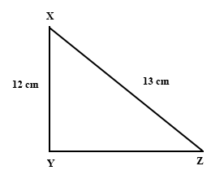
A.
25 cm
B.
14 cm
C.
12.5 cm
D.
5 cm
E.
1 cm

25.

Write 1204_{five} as a number in base ten.
A.
9996
B.
179
C.
39
D.
35
E.
19

26.

Multiply (2x + y) by (2x – y)
A.
4x² – 4xy – y²
B.
4x² + xy – y²
C.
4x² – xy – y²
D.
4x² + y²
E.
4x² – y²

27.

A watchman was paid a basic wage of ₵250.00 a day. If he worked every day in the month, calculate his basic wage for February 1988.
A.
₵6250.00
B.
₵7200.00
C.
₵7250.00
D.
₵7750.00
E.
₵8750.00

28.

A tank contains 250 litres of water. If 96 litres are used, what percentage of the original quantity is left?
A.
61.6%
B.
60.5%
C.
59.0%
D.
54.2%
E.
38.4%

29.

Evaluate 10 ÷ (3
1
2
+ 1
1
5
)
A.
2
6
47
B.
4
2
35
C.
4
D.
2
1
6
E.
4
7
10

30.

A bag contains 24 marbles, 10 of which are blue and the rest green. A boy picks a marble at random from the bag. What is the probability that he picks a green marble?
A.
1
14
B.
7
17
C.
5
12
D.
7
12
E.
7
10

31.

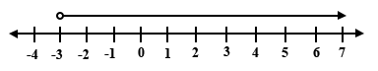
Which of the following inequalities is represented on the number line, where n is a real number?
A.
n ≥ -3
B.
n < -3
C.
n ≤ -3
D.
n > -3
E.
n = 3

32.

What is the name of the line segment drawn to join any two points on the circumference of a circle?
A.
arc
B.
chord
C.
radius
D.
sector
E.
segment

33.

Use the mapping below to answer the question below.
(
1
2
) → (1) → (3.14)
(1) → (2) → (6.28)
(2) → (4) → (12.56)
(3) → (6) → (x)
(y) → (10) → (31.4)
Find the value of x
A.
9.42
B.
12
C.
18
D.
18.84
E.
25.12

34.

Use the mapping below to answer the question below.
(
1
2
) → (1) → (3.14)
(1) → (2) → (6.28)
(2) → (4) → (12.56)
(3) → (6) → (x)
(y) → (10) → (31.4)
Find the value of y
A
A.
2
B.
5
C.
7
D.
9
E.
10

35.

The area of a square is 49 cm² . Find the perimeter of the square.
A
A.
7 cm
B.
14 cm
C.
28 cm
D.
49 cm
E.
196 cm

36.

The least number in a set of real numbers is 24 and the greatest is 30. Which of the following is the correct interpretation of the statement?
A.
24 ≤ x ≤ 30
B.
24 < x < 29
C.
23 < x < 29
D.
24 < x < 30
E.
23 ≤ x ≤ 29

37.

Find the area of the trapezium MNOP.
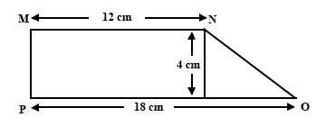
A.
120 cm²
B.
72 cm²
C.
60 cm²
D.
48 cm²
E.
38 cm²

38.

The length of a field, 1.2 km long is represented on a map by a line 40 mm long. What is the scale of the map?
A.
1 : 100
B.
1 : 300
C.
1 : 1000
D.
1 : 3000
E.
1 : 30000

39.

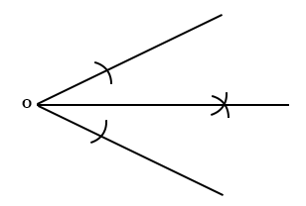
The diagram above shows the construction for:
A.
Copying a given angle
B.
Bisecting a line segment
C.
Drawing a perpendicular to a given line
D.
Bisecting a given angle
E.
Drawing an angle of 30°
Mark
40.

Simplify
(
2
-3
)
-
(
-1
5
)
A.
(
-3
8
)
B.
(
3
-8
)
C.
(
-3
-8
)
D.
(
3
8
)
E.
(
-3
2
)
Mark

